**PAYMENT TRENDS**

**Introduction:**

This report presents an analysis of our transaction data, focusing on the frequency of records based on their creation and paid dates, as well as the time lag between record creation and payment. By examining these trends, we aim to uncover insights that will help us improve cash flow, optimize our processes, and anticipate future trends in transaction volume.

**Segment 1: Record Creation and Payment Patterns**

**Overview:**

To gain a broad perspective of our transaction activity, we compared the frequency of records based on their creation and paid dates over time.

**Key Insights:**

* **Steady Growth and Spike in Record Creation**:  
  The data shows a steady increase in record creation towards the end of 2023, culminating in a dramatic spike in early 2024. This suggests a rise in transactional activity during this period, potentially reflecting seasonal trends or a surge in business.
* **Lag in Payment Dates**:  
  The orange bars in the graph, which represent the paid dates, follow a similar trajectory but with a noticeable lag behind the creation dates. This delay highlights the natural gap between when records are created and when payments are processed.
* **Peak Activity in Early 2024**:  
  The peak in both record creation and payments occurred between January and March of 2024. This surge in activity may indicate a recurring seasonal pattern or a unique spike in demand during this period.

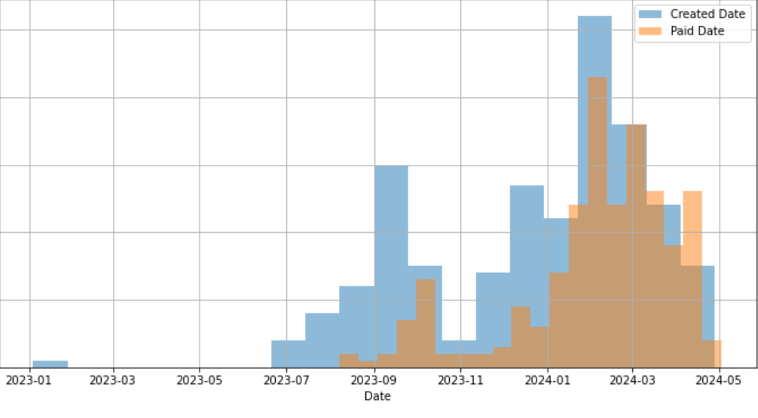

**Key Point to Emphasize:**  
This insight allows us to forecast busy periods, helping us better allocate resources and prepare teams for increased demand in future peak periods.

**Segment 2: Payment Lag Analysis**

**Overview:**

Next, we analyzed the time lag between when records are created and when payments are made, identifying trends and potential bottlenecks in our payment process.

**Key Insights:**

* **Majority of Payments Within 50 Days**:  
  The majority of payments are made within the first 50 days of record creation, indicating that most transactions are processed relatively quickly.
* **Outliers with Delayed Payments**:  
  Despite the majority falling within this 50-day window, there are some outliers where payments are delayed significantly. These delayed payments can create bottlenecks in our cash flow and require further investigation to determine the cause.

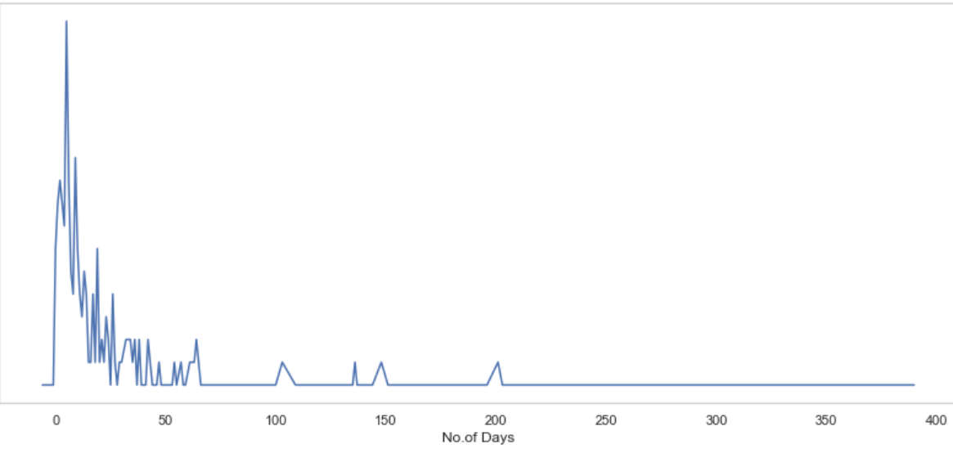

**Key Point to Emphasize:**  
Understanding the payment lag is crucial for identifying areas where we can improve our cash flow. If we focus on reducing the time between record creation and payment, we can streamline operations and boost financial efficiency.

**Proposed Solutions:**

Based on the insights gained from our analysis, the following solutions are recommended to address payment delays and optimize the payment process:

1. **Set Clear Payment Terms**:  
   **Solution**: Ensure that payment terms are clearly defined at the beginning of each transaction. These terms should be communicated effectively to both clients and internal teams, with explicit deadlines for all parties to follow.  
   **Impact**: By setting and reinforcing clear payment expectations upfront, we can reduce delays due to misunderstandings or ambiguous expectations. This will help payments proceed more smoothly, minimizing unnecessary delays.
2. **Implement Real-Time Tracking**:  
   **Solution**: Utilize a real-time payment tracking system that monitors the status of each payment in the pipeline. Automated alerts can be set for any payment that exceeds a specified timeframe, allowing for quick intervention to resolve potential delays.  
   **Impact**: Real-time tracking will enable proactive management of payments. By identifying and addressing delays early, we can prevent them from escalating into larger issues, ensuring timely payments and reducing bottlenecks.
3. **Offer Early Payment Incentives**:  
   **Solution**: Introduce early payment incentives, such as offering small discounts to clients who settle their payments ahead of the due date.  
   **Impact**: Early payment incentives encourage clients to pay sooner, effectively reducing the overall payment cycle. This will help improve our cash flow and ensure a steady inflow of funds.